Community Trust Index in Nepal
An evidence-based tool for measuring and fostering trust in humanitarian action.
Synthesis Report (Phase 1 & 2)

February-May 2025 |  | Community Engagement and Accountability

Abbreviations:
IFRC: International Federation of the Red Cross and Red Crescent Societies
CTI: Community Trust Index
NRCS: Nepal Red Cross Society
EWS: Early Warning System
RCRC: Red Cross and Red Crescent
Contents
Executive Summary 2
Context: 3
Trust Index Modules 3
CTI Modules in Nepal 4
Methodology 5
Sampling 5
Data Protection/ ethical consideration: 5
Data Collection 6
Limitations 7
Findings on institutional Trust 8
Community trust by population profile 8
Trust in National Society Competence 9
Trust in National Society Values/Ethics 9
Trust on NRCS Feedback Mechanism and Integrity 10
Community Trust on Transparency and Neutrality 10
Community Experiences and Intention 11
Score by factors 12
Findings from Early Warning Module 15
Warning Dissemination & Communication 15
Preparedness & Response Capabilities 15
Community Experience on Early Warning: 16
Channel to receive early warning 17
Score by Demography 17
Score by Geographical area 18
Strengths and challenges of CTI in Nepal: 20
Recommendations from stakeholders and community to Strengthen Trust in NRCS 21

Executive Summary

Introduced in 2022 by the International Federation of the Red Cross and Red Crescent Societies (IFRC), the Community Trust Index (CTI) provides a standardized approach to measure and strengthen trust in humanitarian action. It treats trust as measurable and shaped by what humanitarian actors deliver and how they behave, across two dimensions: competencies (organization’s efficiency, skills, and abilities), and values/ethics (alignment with people’s beliefs and preferences). Thirteen National Societies are engaged in applying the Trust Index across Africa, the Americas, Asia Pacific, and Europe – generating evidence that identifies trust gaps, targets interventions more effectively, and tracks progress over time.
With support from IFRC and the British Red Cross, the Nepal CTI piloted an integrated application of two modules (Institutional Trust and Early Warning & Anticipatory Action) on a shared sample, a methodological first. Implementation followed a phased approach across diverse geographic contexts: Phase 1 covered the western districts of Banke, Bardiya, Kailali, and Kanchanpur; Phase 2 focused on the Kathmandu Valley. Together, the two phases reached 3,538 respondents across seven districts, administered by 68 trained NRCS volunteers using a mixed-methods design combining household surveys, 11 focus group discussions, and 16 key informant interviews.
Institutional Trust: A Strong Foundation with Structural Gaps
NRCS achieved an overall trust score of 7.1/10, underpinned by decades of visible humanitarian action – from the 2015 earthquake response to the COVID-19 pandemic and ongoing blood services. Competencies scored 7.2/10, with Capability (7.64), Accessibility (7.37), and Responsiveness (7.33) all rating strongly. Values and ethics scored 6.9/10, led by Inclusiveness (7.74), Fairness (7.62), and Respectfulness (7.55).
However, two dimensions consistently underperformed across all groups. Transparency scored just 5.02/10 – the lowest of all measured dimensions – with only 38% of respondents believing NRCS openly shares information about its decision-making. Integrity scored 5.69/10. On political neutrality, just 44.6% of respondents expressed positive perceptions, while 32.9% expressed doubts and 22.6% were unsure, a particularly acute concern in urban areas where political awareness is higher.
Accountability infrastructure is nearly invisible to communities: 71.7% of respondents are unaware that an NRCS feedback mechanism exists. Among those who are aware, only 10.7% have ever used it – though 79.7% of users were satisfied with how their feedback was handled, pointing to a quality mechanism that lacks reach rather than a broken system.
Community Engagement with the NRCS: Goodwill Without Pathways
Community interaction with NRCS is primarily defined by receiving rather than contributing. While 42.8% of respondents have received aid or support, 84.9% have never volunteered and 76.1% have never donated. Yet intentions signal significant untapped potential: 89% intend to follow NRCS advice in a future crisis (compared to 24.2% who have done so), 63.9% intend to donate, and 62.8% intend to volunteer – a fourfold gap between current and intended volunteerism. Converting this goodwill into action requires clearer pathways and visible feedback channels.
Early Warning Systems: Effective Delivery, Weak Participation
The EWS module was applied across Pillars 3 and 4 (warning dissemination & communication and preparedness & response). Both pillars show the same structural pattern: competency-related dimensions perform relatively well while value-related dimensions lag. Across combined scores, Effectiveness (6.34), Feedback (6.36), and Inclusiveness (6.31) are strongest; Participation (5.32) and Transparency (5.12) are weakest – consistent with findings from the institutional trust module.
Warning reach remains uneven: 45.8% of respondents received NRCS warnings, while 43.9% did not. Official channels dominate – local authorities (84.7%) and the Red Cross (81.2%) are the most widely used – while social media (35.6%) ranks lowest. Critically, receiving a warning has a demonstrable trust-building effect: respondents who received NRCS warnings scored 7.17/10 on communication and 7.22/10 on preparedness, compared to 4.78 and 5.01 respectively for those who did not – a gap of more than two points.
Geographic and demographic disparities are pronounced. Rural communities outperform urban areas in both institutional trust (competencies: 7.89 vs. 6.5) and EWS scores (warning dissemination: 6.60 vs. 5.58). Banke District leads all districts in institutional trust (competencies: 8.39; values: 8.06), while Kathmandu District records the lowest scores (competencies: 6.5; values: 6.16) – a pattern that persists across the EWS module (Kathmandu preparedness: 4.99; communication: 4.75).
Priority Areas for Action
The findings converge on four areas requiring targeted investment: strengthening transparency and accountability mechanisms with greater community visibility; expanding the reach and awareness of feedback channels, particularly in urban and underserved areas; investing in last-mile warning dissemination in Kathmandu, Lalitpur, and among older and lower-educated populations; and systematically converting community goodwill into sustained engagement through drills, volunteer mobilization, and repeated touchpoints. Each of which the data shows directly builds trust.

Introduction
Trust is the foundation of the Red Cross and Red Crescent (RCRC) Movement. Trust in humanitarian action is strongly linked to fostering acceptance of support and assistance, which subsequently improves security, increases access to affected people, and enables National Societies to assist those in need in an unbiased manner. For NRCS, community trust determines whether people seek humanitarian services, act on early warnings, volunteer time, donate resources, and accept assistance during crises. In Nepal's complex political landscape, trust cannot be taken for granted; it must be measured, earned and maintained through consistent, principled action.
  - Country Context and the NRCS Work
Nepal is a low-income federal republic shaped by political transitions, social inequalities, and structural poverty, with development gains remaining fragile due to reliance on agriculture and remittances. Within this context, the Nepal Red Cross Society (NRCS), established in 1963, has become the country’s leading humanitarian actor. Over six decades, NRCS has responded to major crises, including the 2015 earthquake and the COVID-19 pandemic, mobilizing thousands of volunteers and coordinating with partners such as the International Federation of Red Cross and Red Crescent Societies, International Committee of the Red Cross, American Red Cross, and the Ministry of Health and Population.
Nepal is among the world’s most disaster-prone countries, facing earthquakes, floods, and climate-driven hazards. Flooding is the most severe hazard in Nepal in terms of physical and socioeconomic losses. Major river systems – Koshi River, Karnali River, and Narayani River – regularly affect multiple districts across the southern Terai. Rivers such as the West Rapti River and Babai River, originating in the Mahabharat Range, frequently trigger monsoon flash floods that intensify damage in lowland floodplains.
Despite these challenges, NRCS maintains an extensive national footprint that is unmatched among Nepalese civil society organisations, operating through provincial and district structures supported by over 100,000 volunteers, 1.2 million members, and hundreds of staff. Its nationwide services include disaster risk management, community health, blood transfusion, ambulance services, eye care, first aid, and humanitarian values promotion.
  - Understanding the Community Trust Index
Nepal Red Cross Society (NRCS) applied Community trust index (CTI) as an evidence-based tool for measuring and fostering trust in humanitarian action. The Community Trust Index, developed by IFRC, measures trust along two dimensions:
- Competencies: Measures perceptions of NRCS's capability, timeliness, accessibility, awareness of community needs, responsiveness to feedback, openness to dialogue, and effectiveness in delivering assistance.
- Values/Ethics: Measures perceptions of NRCS's transparency, neutrality, fairness, integrity, respect, inclusiveness, kindness, and community participation.
Both dimensions matter because an organization can be technically competent but untrusted if communities question its motives or ethics. Conversely, good intentions without capability to deliver erode trust over time. Sustainable trust requires strength in both areas.
This assessment used two CTI modules:
- Institutional Trust: Community perceptions of NRCS as an organization. Measures community perceptions of NRCS’s capacity to deliver timely and effective support, understand local needs, and act with fairness, inclusiveness, transparency, and integrity.
- Early Warning & Anticipation: Assesses trust in NRCS’s early warning systems and disaster preparedness communications. It explores confidence in forecast and risk information, early warning mechanisms, and the actors involved in early warning and anticipatory action.
Together, these provide a comprehensive picture of how communities perceive NRCS's role before, during, and after crisis.

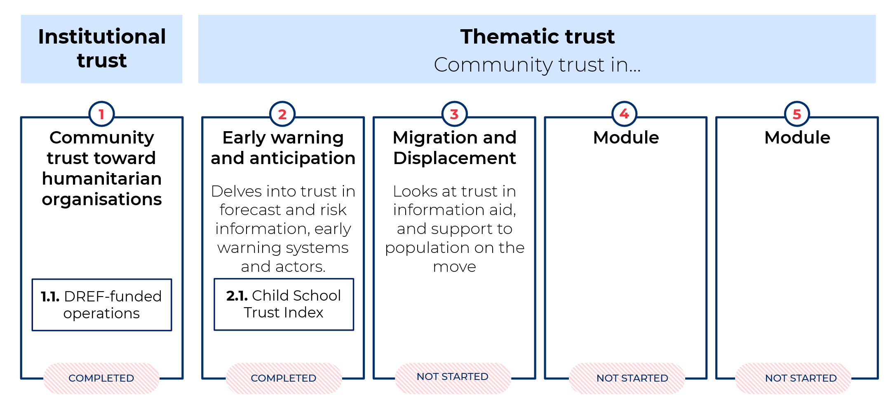

This survey is an essential tool in understanding how organization and its services are perceived by the communities it serves and identifying areas where trust can be strengthened. CTI was implemented using mixed methods capturing perspectives from flood-prone urban and rural settings. Initially, the first phase CTI was completed in four districts: Banke, Bardiya, Kailali and Kanchanpur. Up to two or three municipalities were selected in each district covering at least one urban and one rural municipality. The second phase CTI was conducted in Kathmandu Valley Districts to understand the perception of community towards the organization in the urban context. Districts were selected based on the high impact of disasters and high risk of flood, districts affected by climate change and districts with preparedness and response programme. Data collection was done using the kobo tool through volunteer mobilization in all selected Districts. Training on data collection techniques was provided to the volunteers along with a briefing on the questionnaire and field tests were done before they were mobilized in the community.

Methodology
  - Study design
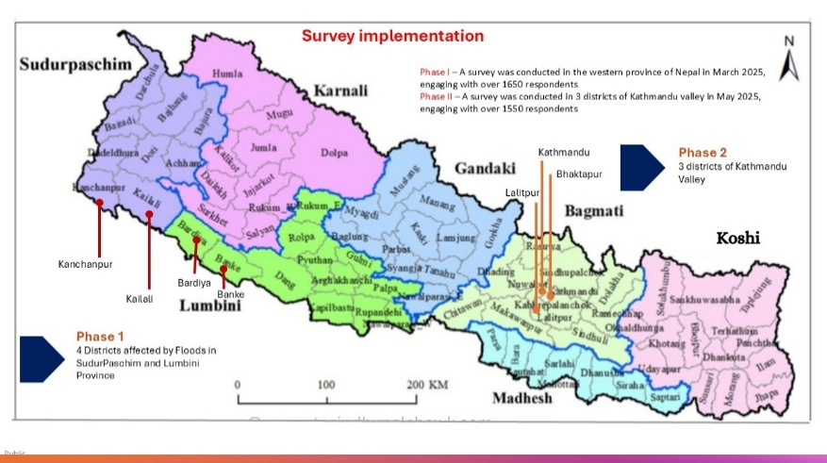
The Trust Index employed a mixed-methods approach combining quantitative and qualitative techniques to capture both measurable trends and deeper contextual insights. The quantitative component used Kobo Toolbox. It consisted of close-ended questions with predefined response options, enabling statistical analysis of community perceptions across key trust dimensions and supporting calculation of the Trust Index scores.
The qualitative component used open-ended questions to generate detailed explanations of the reasoning behind community perceptions – specifically the “why” and the key drivers shaping trust. This component included Focus Group Discussions (FGDs) and Key Informant Interviews (KIIs) to explore how and why communities trust NRCS and its early warning systems, and to identify areas for improvement.
For the institutional trust module, two separate tools were developed: quantitative household questionnaire, ana a qualitative guide for FGDs and KIIs. For the early warning module, a single integrated tool was used, combining quantitative questions with qualitative open-ended follow-up questions to capture both measurable responses and explanatory insights.
  - Sampling and data collection
This study has applied random stratified sampling techniques, where the population is divided into distinct subgroups called strata, which share certain characteristics. After dividing the population, a random sample is drawn from each stratum. This method ensures that each subgroup is represented proportionally in the sample, providing a more accurate representation of the entire population.
Respondent were selected based on characteristics such as gender (male and female), age group (18-39, 40-59 and 60+), and education level (no formal education, primary, secondary and university level) with additional distinctions made between rural and urban municipalities to ensure representation across diverse communities. Table 1 below shows the detailed sample size by district and municipality.
Table1: Sample size per selected district and Municipalities/ Rural Municipalities for CTI survey.
Province | District | Palika | Sample size | Field Date
Sudurpaschim | Kailai | Gauriganga M  Kailari RM  Bhajani | 607 respondents | 20-30 March 2025
Sudurpaschim | Kanchanpur | Punarbas M  Laljhadi RM  Belouri | 341 respondents | 20-30 March 2025
Lumbini | Banke | Duduwa RM  Nepalgunj M | 412 respondents | 20-30 March 2025
Lumbini | Bardiya | Gulariya M  Geruwa RM  Rajapur M | 319 respondents | 20-30 March 2025
Bagmati | Kathmandu | Kathmandu Metro  Budhanilkantha M  Tarkeshwor M  Nargajun M  Chandragiri  Kirtipur  Shankarapur  Kageshowari | 1051 respondents | 15-22 May 2025
Bagmati | Lalitpur | Lalitpur Metro  Mahalaxmi  Godawari | 307 respondents | 11-18 May 2025
Bagmati | Bhaktapur | Changunarayan Madhyapur Suryabinayak | 238 respondents | 11-18 May 2025

The survey was conducted by the Nepal Red Cross Society (NRCS) in April and May 2025 as part of the Community Trust Index project. NRCS volunteers administered the questionnaire, focusing on issues of trust within the framework of the Building Trust initiative. In total, the survey reached 3,538 respondents across selected districts in the western provinces and the Kathmandu Valley. For quantitative data collection 68 volunteers from the respective areas were trained and mobilized to conduct the CTI survey at the household level.
To maintain the quality and consistency of the data, regular monitoring of data was conducted throughout the data collection period. This helped track the disaggregated data by sample and geographic area. After completion of the field level data collection, data extraction from Kobo Toolbox and cleaning of raw data was done before the analysis of the findings.
Along with the household survey, KII was done with 10 District level stakeholders and 11 FGD were conducted with the community members at different selected districts. NRCS has also conducted 6 KII at national level government officials.

Data Protection and ethical consideration
Personal data were collected to ensure they are adequate, relevant, accurate, and not excessive for the specific purpose of the CTI assessment. Personal data were stored electronically and retained only for the period necessary to fulfill the specified purpose. Any future use of the data requires prior approval and clear justification.
During the processing of personal data, appropriate measures were taken to ensure confidentiality of l data. The data were secured and protected against data breaches. All the personal identifiers (e.g. name, age, address, sex, etc.) were encoded to protect respondent confidentiality.To transfer personal data to third parties, a written agreement needs to be done, specifying that the data would be used only for the stated purpose, returned or destroyed after completion of the task, and protected through appropriate safeguards to prevent unauthorized access.

Limitations
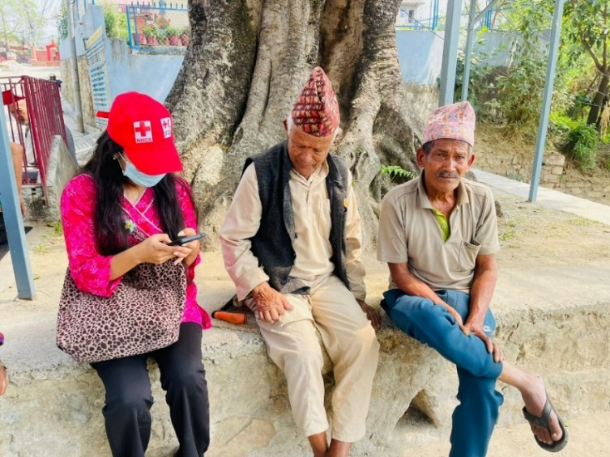
The data presented in this study should be interpreted with caution due to methodological limitations related to sampling and representativeness. While the survey provides valuable insights, certain groups and regions overrepresented or underrepresented compared with census distributions. For example, Sudur Paschim province is over-represented, women aged 40+ are slightly under-represented, and older men are over-represented. Similarly, disparities exist across education levels, employment categories, and district representation. To reduce these imbalances, post-stratification adjustments were applied using key variables such as age, gender, education, and employment status. These corrections improve comparability but cannot fully eliminate bias arising from the sampling design. As a result, the findings should be viewed as broadly indicative rather than fully representative of the wider population, and caution is advised when generalizing the results beyond the study sample.
Photo 2: CTI survey at Bhaktapur

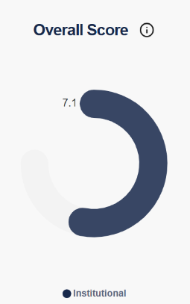
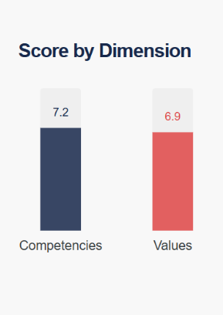
Key Findings on Institutional Trust
The Community Trust Index Survey conducted by the Nepal Red Cross Society reveals varying levels of trust across different regions and demographic groups. The NRCS achieved an overall trust score of 7.1/10, reflecting strong public trust built over decades of humanitarian action – most notably its response to the 2015 earthquake, the COVID-19 pandemic, and its ongoing blood donation services.
Competencies scored slightly higher at 7.2, capturing positive perceptions of NRCS's capability, timeliness, accessibility, and responsiveness. Values and ethics scored 6.9, reflecting how communities perceive the organization's transparency, fairness, neutrality, and inclusiveness – areas that, while solid, present the greatest opportunity for strengthening trust further.
Trust levels were consistently higher in rural areas, where communities cited timely service delivery, strong local presence, and clear communication. Conversely, comparatively lower scores were observed in urban areas pointing to gaps in community engagement and feedback mechanisms. Overall, the findings underscore both the sustained impact of NRCS’s work and specific areas where targeted improvements could further strengthen community trust and participation.
Overall, the findings underscore both the positive impact of NRCS work and specific areas where targeted improvement could further strengthen community trust and participation.
Qualitative data from KIIs and FGDs reveal that trust is closely tied to visible results and consistent follow-through. As one participant observed, trust grows when organizations…
"Show results through their work... say they will do something and do it" (Male, KII, Kathmandu City Ward 16).
To sustain this, participants stressed that future trust-building must be grounded in regular community engagement, transparent communication about available services, and needs-based support:
“Organize regular meetings, exchange information, gather people at the community level, inform the public about services and support the Red Cross offers (…) not just in select areas but everywhere." Crucially, "continuity is essential" (FGD, Tarkeswor Municipality Ward No. 5).

Trust in National Society Competencies
Respondents rated their level of trust in competencies on seven questions intended to measure the perception on the National Society capability, timeliness, knowledge, openness, welcoming complaints, providing relevant/useful information, and effectiveness. Overall, the results suggest a moderate to strong level of trust in the operational competencies of the Nepal Red Cross Society.
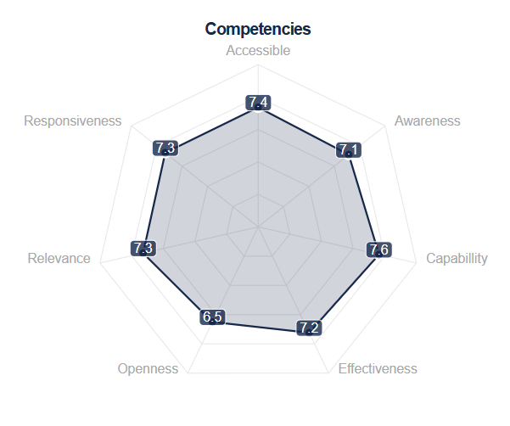
Among the competency dimensions, Capability (7.64) received the highest score, indicating that respondents generally believe NRCS has the technical and organizational capacity to help people effectively. Accessibility (7.37) and Responsiveness (7.33) also scored strongly, suggesting that communities perceive NRCS as approachable and able to respond in a timely manner when support is needed. These findings reflect positive perceptions of NRCS’s frontline presence and service delivery.
Figure 2: Trust in NRCS Competencies
However, Openness (6.5) received the lowest score, followed by Awareness (7.1). Since Openness relates to whether people feel comfortable raising complaints or feedback, the lower score may indicate barriers in community feedback mechanisms or limited confidence in complaint-handling processes. Similarly, the Awareness score suggests that some respondents may not consistently receive clear or sufficient information about NRCS services and activities.
Overall, while the findings confirm strong trust in NRCS’s operational capacity and responsiveness, they also point to opportunities to strengthen two-way communication, information-sharing, and complaint systems to further improve community engagement and institutional trust.

  - Trust in National Society Values/Ethics
Community trust in the values and ethics of the NRCS are measured through the eight questions related to transparency, neutrality, fairness, integrity, respectfulness, inclusiveness, kindness, engagement, alongside additional perception questions on transparency and neutrality.
Overall, the findings indicate generally positive perceptions of NRCS’s value-based service delivery, particularly in areas related to equitable and respectful treatment of communities.
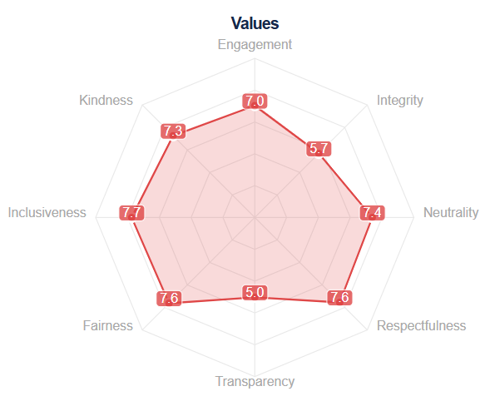
Among the measured dimensions, Inclusiveness (7.74) received the highest rating, followed by Fairness (7.62) and Respectfulness (7.55), with Neutrality (7.4) also scoring relatively strongly. These results suggest that respondents largely perceive NRCS as providing assistance without discrimination, prioritizing those most in need, and treating people with dignity. This reflects strong alignment with humanitarian principles at the community level.
Figure 3: Trust in NRCS Values/Ethics
In contrast, Transparency (5.02) and Integrity (5.69) scored comparatively lower, suggesting less consistent confidence in organizational openness and accountability. These lower scores may reflect limited public visibility of decision-making processes and institutional communication rather than direct negative experiences. The findings suggest a need to strengthen communication around organizational processes, decision-making, and accountability practices.
Further analysis of perception questions on transparency shows moderate confidence overall. The largest proportion of respondents (38%) answered “Mostly Yes” regarding transparency in decision-making, while 18% expressed strong confidence (“Yes”). At the same time, 27% reported lower confidence (“Not so much” or “Not at all”), and 17% indicated uncertainty (“Don’t Know”), highlighting opportunities to improve clarity and information-sharing.
Perceptions of impartiality are generally strong, with 85.7% of respondents reporting positive trust levels and 75.2% affirming that support is provided impartially. Perceptions of general neutrality is also relatively high, with 72.3% positive responses, although 15.9% expressed lower confidence.
However, political neutrality emerges as the weakest area within the values dimension. Only 44.6% of respondents expressed positive perceptions, while 32.9% reported doubts and 22.6% were unsure. This suggests that although NRCS is widely viewed as fair and impartial in service delivery, perceptions related to political neutrality may require clearer communication and stronger public positioning to avoid misunderstanding.
Overall, the findings indicate strong community recognition of NRCS’s inclusive, fair, and respectful approach, while improvements in transparency, integrity, and communication on neutrality – particularly political neutrality – could further strengthen trust.

  - Trust in NRCS Across Population Profiles and Demographic Groups
Trust in the Nepal Red Cross Society (NRCS) varies significantly across population profiles and demographic groups, including age, gender, area of residence, language, education level, province, district, employment status, and degree of engagement with NRCS (volunteering or receiving support). The analysis highlights how different groups perceive NRCS competencies and organizational values, identifying both strengths and areas requiring improvement.
    - Trust by Population Profile
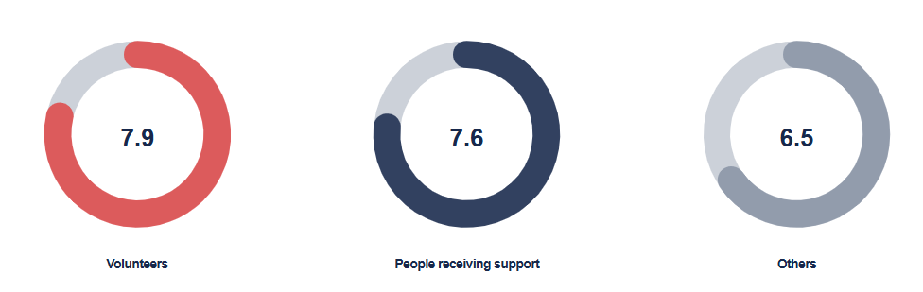
Direct engagement strongly correlates with higher trust. NRCS volunteers report the highest overall trust (7.9/10), followed by individuals who have received support (7.6/10). Community members with no direct relationship with NRCS report notably lower trust levels (6.5/10). This 1.4-point gap signals an awareness and visibility challenge: those less familiar with NRCS activities express lower trust, suggesting that expanding outreach beyond direct beneficiaries could strengthen overall confidence. The volunteer network emerges as a strategic asset, acting as trusted ambassadors who can extend NRCS’s reach and credibility.

Across dimensions, volunteers consistently rate NRCS more positively than beneficiaries and other respondents. Capability receives the highest scores (8.34 from volunteers; 8.29 from others), followed by effectiveness (8.07 from volunteers). However, openness scores lower across all groups, dropping to 6.03 among respondents with no direct engagement.
Regarding organizational values, volunteers rate inclusiveness (8.34) and fairness (8.24) highly. Transparency is the lowest-rated dimension across all groups (4.31 among beneficiaries; 6.03 among volunteers; 5.85 among others). While overall trust is strongest among volunteers, concerns around openness and transparency are consistent across population groups.
    - Trust by Demographic Characteristics
Age analysis shows that trust is highest among youth (values: 7.08; competencies: 7.37) and gradually declines with increasing age, indicating the need for targeted efforts to maintain confidence among older groups. No significant gender differences are observed; however, a notable rural–urban gap exists. Trust levels are higher in rural areas (7.89 in competencies; 7.6 in values) compared to urban areas.

Figure 9: Trust on NRCS by demographic
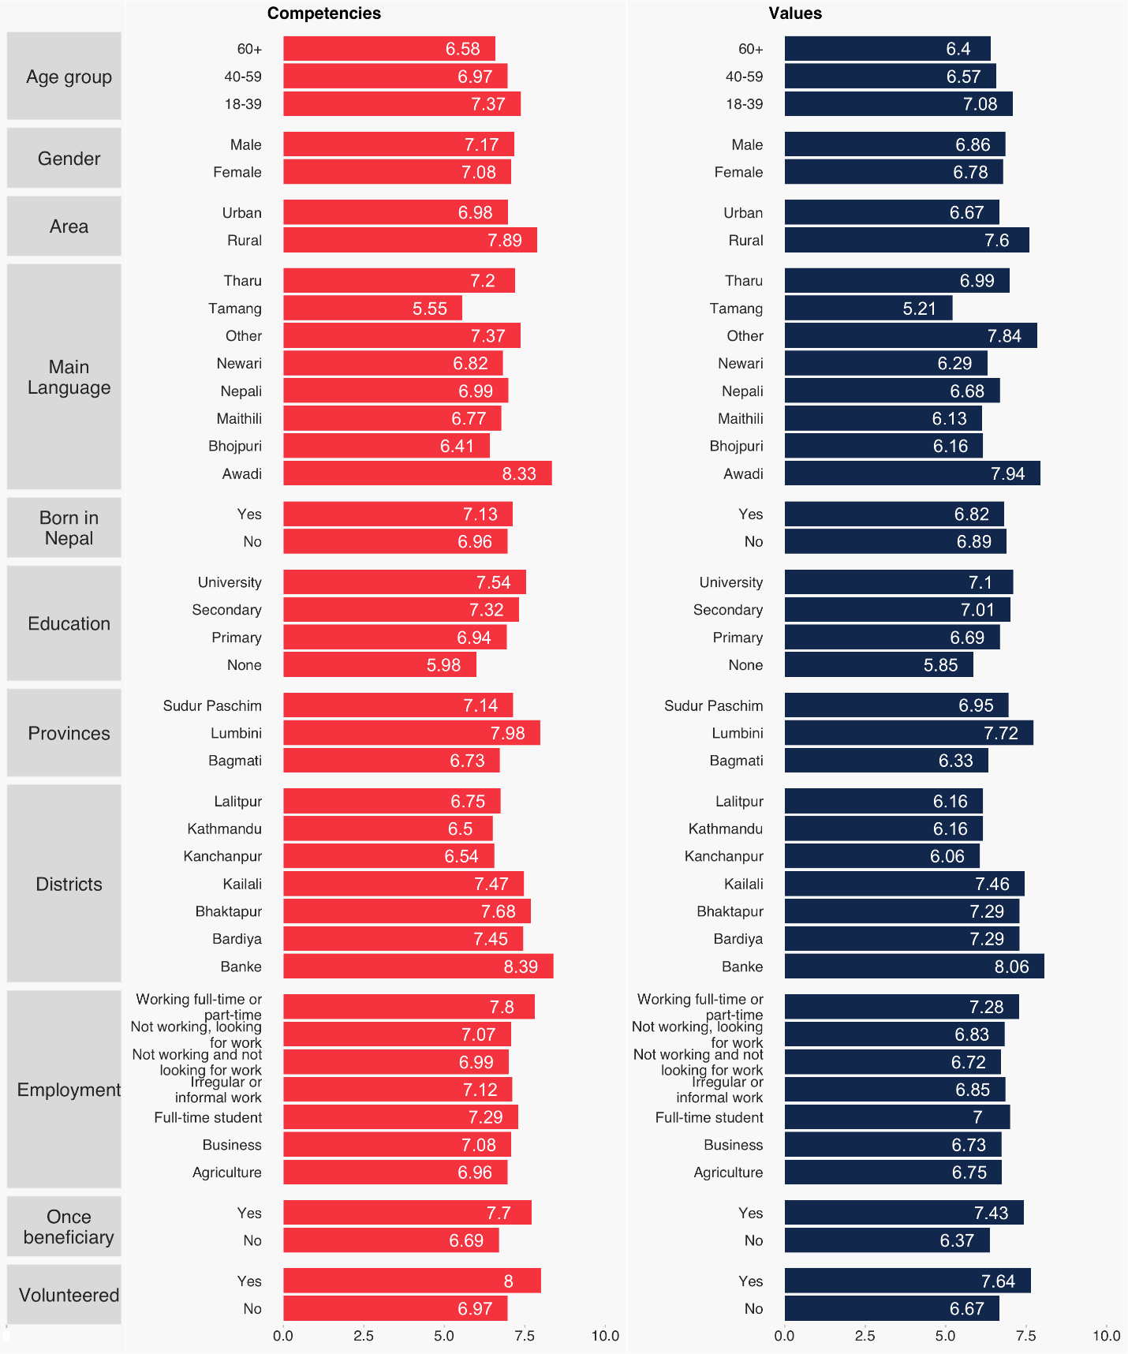
Trust also increases with education level. Competency scores are slightly higher than values scores across all education categories, and the gap between respondents with university education and those with no formal education is significant in both dimensions.
Trust also increases with education level. Competency scores are slightly higher than values scores across all education categories, and the gap between respondents with university education and those with no formal education is significant in both dimensions.
Figure 10: Trust by Education level

    - Regional Variations
Significant geographic differences are observed. Banke District records the highest performance in both competencies (8.39) and values (8.06), followed by Lumbini Province (7.98 competencies; 7.72 values), Bhaktapur District, and Bardiya District. Conversely, Kathmandu District and Kanchanpur District show the lowest scores (competencies at 6.5 and 6.54; values at 6.16 and 6.06 respectively), indicating areas requiring targeted strengthening.
Figure 11: Trust by district and province
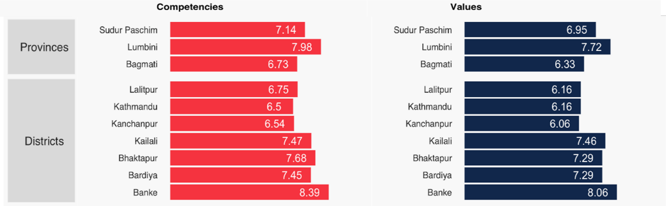

    - Trust by Ethnicity and Language Group
Trust levels also differ across ethnicity and language groups. Awadi and “Other language” groups score highest across both competencies and values, with Awadi recording the strongest results (8.33 and 7.94 respectively). Tamang respondents score lowest in both competencies (5.55) and values (5.21), revealing substantial perception gaps. Other groups, including Tharu, Nepali, Newari, Maithili, and Bhojpuri, fall within a moderate range, suggesting the need for targeted engagement strategies to strengthen perceived competencies and value alignment among lower-scoring communities.
Figure 12: Trust by Ethnicity
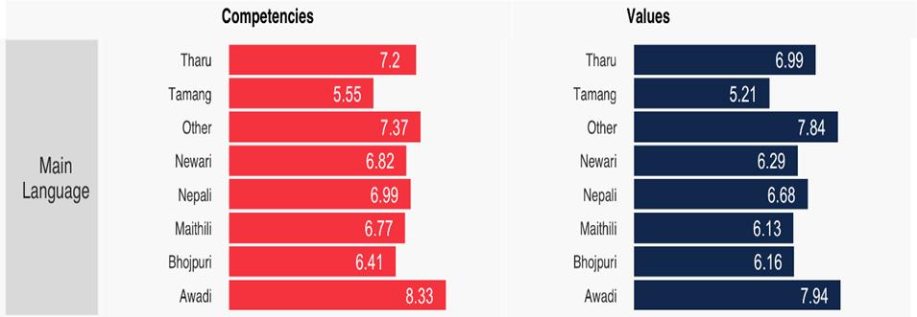
Overall, trust in NRCS is strongest among those directly engaged, younger populations, rural residents, and more educated groups. However, consistent concerns around transparency and openness, alongside demographic and regional disparities, point to priority areas for strategic action.

Additional findings

Beyond the core Community Trust Index scores, this section presents supplementary findings on community awareness of feedback mechanisms, perceptions of integrity and neutrality, and patterns of community engagement with NRCS.

Trust on NRCS Feedback Mechanism and Integrity
An effective feedback mechanism is a cornerstone of accountability. The data reveals a critical awareness gap that limits communities' ability to engage with NRCS on their own terms. Trust Index data shows that accountability infrastructure is nearly invisible to communities:
71.7%  unaware a feedback mechanism exists | 10.7%  of all respondents have ever used it | 79.7%  of users were satisfied with how feedback was handled

The finding that 71.7% of respondents are unaware that a feedback mechanism exists indicates a critical need for broader dissemination and community outreach. While the quality of the mechanism is evidenced by the 79.7% satisfaction rate among users, its impact is substantially limited by low awareness. Expanding visibility of the mechanism, particularly in underserved communities, should be a near-term priority.
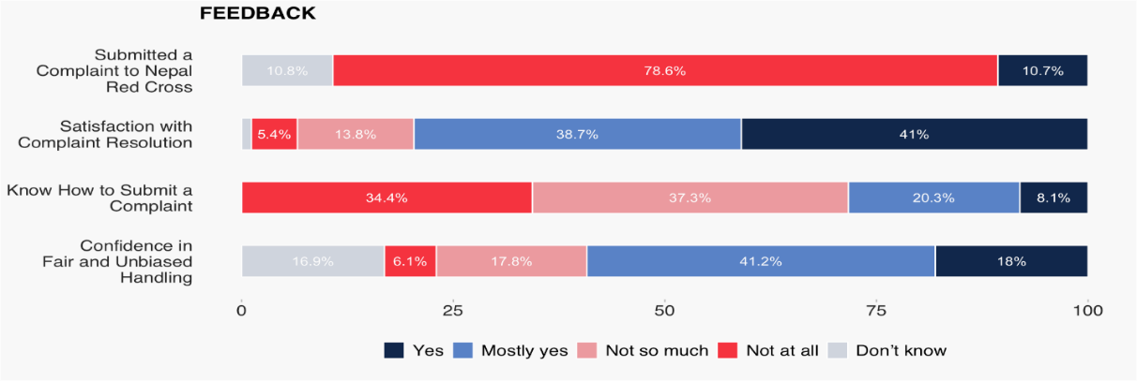

Figure 4: Trust in NRCS Feedback Mechanism
KII data shows a clear preference for confidential, technology-enabled feedback mechanisms. As one respondent noted when how easy it was to provide feedback: “Not really. It doesn’t seem easy – we need to make it easier… “You should implement QR codes for feedback. ‘If you have any thoughts, scan this and submit them. Your response will remain confidential.’ That way, you might get the real picture of what’s happening.” (KII health administrator, Male, Katmandu)

Transparency in Decision-making
Figure 5: Trust on transparency
Respondents were asked whether they perceive NRCS decision-making as transparent. Responses reflect a broadly positive. Overall, 56% of respondents ("Yes" + "Mostly Yes") believe decisions are made transparently, while 27% express some or strong scepticism. The 17% who responded "Don't Know" suggests a segment of the community with limited visibility into NRCS operations, an opportunity for proactive communication.

Neutrality and Impartiality
Figure 6: Trust on Neutrality
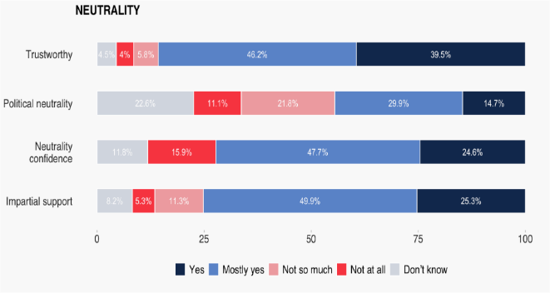
Overall trust and impartiality are strong, with 85.7% rating trustworthiness positively (“Yes” or “Mostly Yes”) and 75.2% affirming impartial support. Confidence in neutrality is also high at 72.3% positive responses, though 15.9% express low confidence. However, political neutrality is the weakest dimension: only 44.6% (Yes + Mostly Yes) give positive responses, while 32.9% express doubts and 22.6% are unsure. This warrants deliberate messaging to reinforce NRCS's principled approach and political independence.

Engagement with the NRCS: Experience, Behaviours, and Intentions
Taken together, the data presents a nuanced but encouraging picture. Communities largely relate to NRCS as recipients rather than contributors, yet levels of trust and future willingness to engage are high. The main opportunity lies in converting goodwill into sustained, active participation.
- Experience: communities receive more than they give
Community interaction with NRCS is primarily shaped by receiving assistance. While 42.8% of respondents reported having received aid or support, a substantial majority had never donated (76.1%) or volunteered (84.9%).

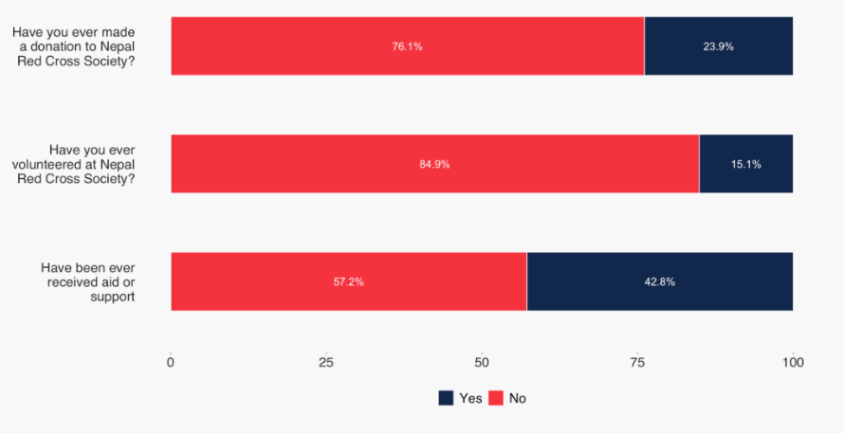
This imbalance suggests that, for many, NRCS is experienced mainly during moments of need. Receiving support defines the dominant mode of engagement and likely underpins the strong trust observed across the dataset. However, contribution-based engagement remains limited.

b) Behaviours: engagement expressed selectively
Despite limited formal participation, behavioural indicators show meaningful engagement. A striking 70.9% reported recommending NRCS to someone in need, reflecting strong interpersonal endorsement. Additionally, 80.4% had provided feedback and 82.3% had applied for services.
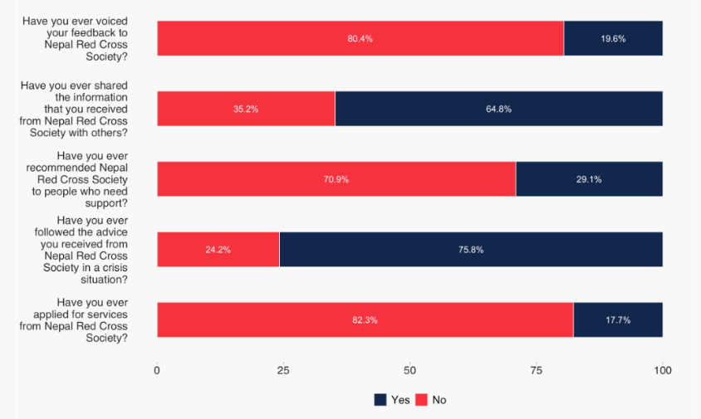
However, more proactive behaviours are weaker. Only 35.2% had shared NRCS information with others, and just 24.2% had followed NRCS advice during a crisis. This suggests communities engage readily when interacting directly with NRCS but are less likely to act as information multipliers or crisis-time followers.

- Intentions: high willingness, limited action
Intentions signal significant untapped potential. Across all measured areas, strong majorities express willingness to engage in the future.
- 89% intend to follow NRCS advice in a crisis (compared to 24.2% who have done so).
- 81.8% intend to share information.
- 72.3% intend to recommend NRCS.
- 63.9% intend to donate and 62.8% intend to volunteer, despite very low historical participation.
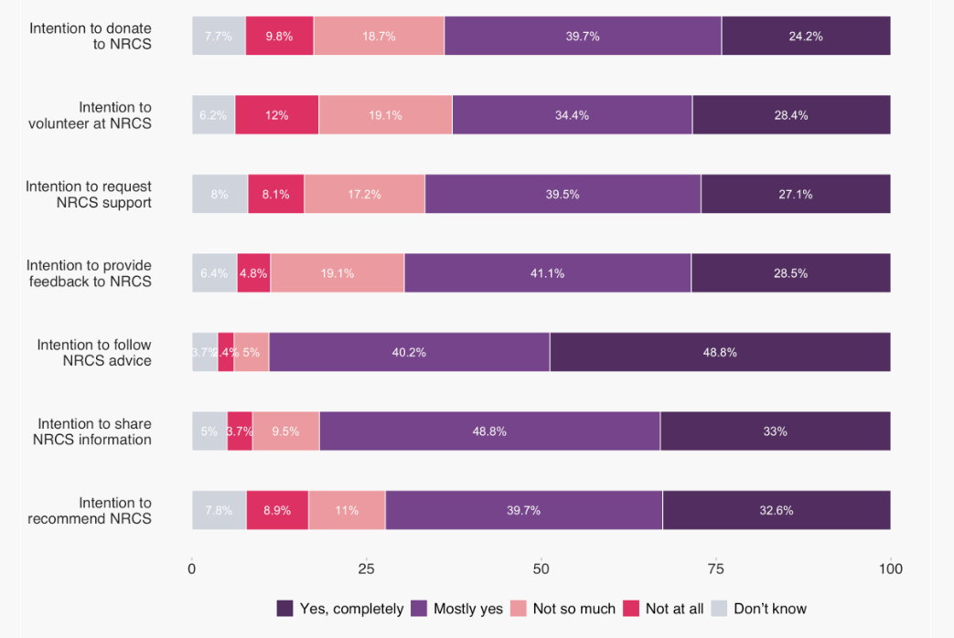

This gap between past behaviour and future intention is striking. Communities are willing to give, participate, and follow guidance, but practical barriers appear to limit action.

PART II: Findings from Early Warning Module
The Community Trust Index module for Early Warning Systems (EWS) aims to strengthen the effectiveness of EWS by producing standardized, actionable evidence on community perceptions across its four pillars: 1) risk knowledge, 2) observation and monitoring, 3) dissemination and communication, and 4) preparedness and response. In Nepal, the Index was applied across pillar three and four: warning dissemination & communication and preparedness & response
Each module is scored across six sub-dimensions derived from the CTI methodology’s two trust dimensions – competencies (responsiveness, effectiveness, openness) and values (participation, inclusiveness, transparency) – rated on a scale from 0 to 10. Higher scores indicate stronger trust, reflecting community confidence that their needs are being addressed and their values respected. The findings presented below draw on survey data collected in Nepal and are organized by module, demographic group, and geography to enable targeted programmatic action.

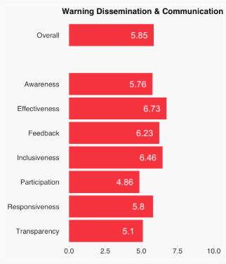
Warning Dissemination & Communication
Across the six sub-dimensions of Warning Dissemination & Communication, community trust is highest for Effectiveness (6.73) and Inclusiveness (6.46), suggesting that communities broadly perceive early warning messages as actionable and accessible. Responsiveness (5.80) and Awareness (5.76) fall in the moderate range, indicating that while warnings generally reach people in time, community-level recognition of warning actors and systems remains incomplete.
The two lowest-scoring sub-dimensions – Participation (4.86) and Transparency (5.10) – reveal the most critical gaps. These scores suggest that communities feel largely excluded from the planning of warning systems and that warning actors do not sufficiently share information about how or when alerts are issued. Addressing these gaps is essential: research consistently shows that participatory design and transparent communication are foundational to community uptake of early warnings.

Preparedness & Response
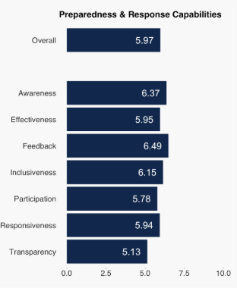
Preparedness & Response scores are generally higher than those for Warning Dissemination & Communication, with Feedback (6.49) and Awareness (6.37) emerging as the strongest sub-dimensions. This indicates that communities have a comparatively clearer understanding of what preparedness actions to take and feel that feedback channels are functional. Inclusiveness (6.15) also scores well, suggesting that response activities are broadly perceived as considering the needs of diverse community members, including vulnerable groups.
Effectiveness (5.95) and Responsiveness (5.94) sit close to the module average, implying moderate but improvable perceptions of how quickly and capably communities can respond when warnings are issued. As with Warning Dissemination & Communication, Transparency (5.13) is the weakest sub-dimension, pointing to a systemic challenge around information-sharing about how preparedness activities are planned and conducted.

Combined pillar scores and across-cutting themes
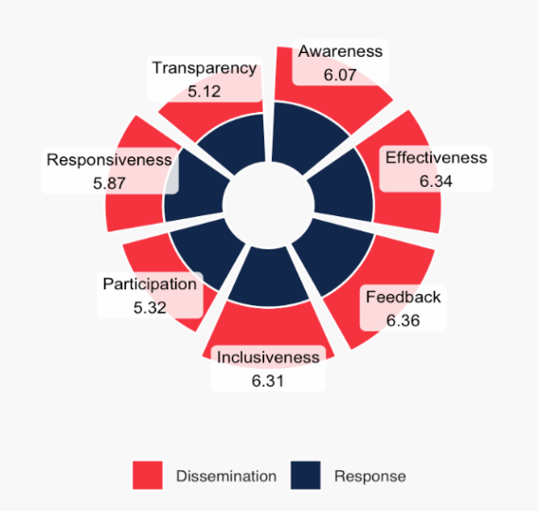
When scores are aggregated across both modules, Feedback (6.36), Effectiveness (6.34), and Inclusiveness (6.31) emerge as the strongest dimensions, while Participation (5.32) and Transparency (5.12) remain the most underdeveloped. This consistent pattern across both modules suggests structural rather than module-specific weaknesses: warning and preparedness actors tend to deliver services effectively but engage communities as recipients rather than partners.
These findings align with the CTI’s framework distinction between competencies and values. While competency-related dimensions (effectiveness, responsiveness) perform relatively well, value-related dimensions (participation, transparency) lag – highlighting that communities trust the technical capacity of EWS actors more than they trust those actors to involve and inform them.
The combined-score chart shows Preparedness & Response generally outperforms Warning Dissemination & Communication, with the highest scores in Feedback (6.36), Effectiveness (6.34), and Inclusiveness (6.31). Awareness is moderate (6.07), while Participation (5.32) and Transparency (5.12) are lowest, highlighting key areas for improvement.

Community Experience with Early Warnings
Survey data reveals significant gaps in the reach of early warning and aid programs. Only 42.8% of respondents confirmed receiving aid or support, meaning that 57.2% of respondents did not benefit directly from formal assistance programs. Similarly, 45.8% reported personally receiving warnings from the Nepal Red Cross Society (NRCS), while 43.9% reported not receiving such warnings – a finding that underscores the importance of strengthening last-mile dissemination. 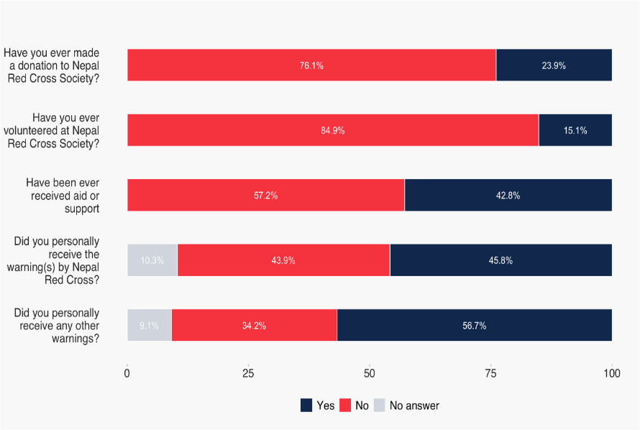
Other warning sources performed comparatively better: 56.7% of respondents received warnings from non-NRCS channels, with 34.2% receiving none at all. This points to the value of a diversified, multi-channel communication strategy.
A key cross-cutting finding is that prior engagement with the EWS – whether through volunteering, receiving a warning, or participating in a program – correlates strongly with higher trust and preparedness scores, reinforcing the case for sustained community involvement.

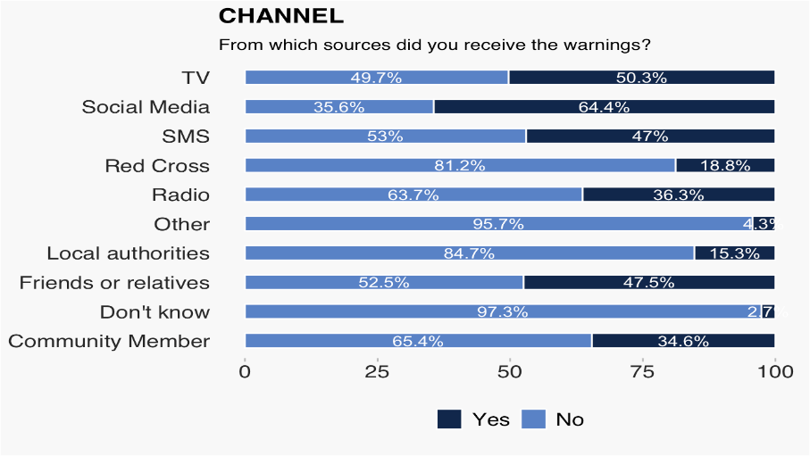
Warning channels
Official and community-based channels dominate warning reception. Local authorities (84.7%) and the Red Cross (81.2%) are the most widely used and reliable sources, followed by community members (65.4%) and radio (63.7%). SMS (53%), friends or relatives (52.5%), and TV (49.7%) reach approximately half of respondents, while social media (35.6%) ranks lowest despite its growing prevalence – suggesting either uneven digital access or limited trust in social media as a warning source.

These findings have practical implications for channel investment: while digital channels (social media, SMS) offer scalability, they cannot yet substitute for trusted in-person and broadcast mechanisms. Strategies to increase warning reach should prioritize strengthening local authority networks and community-based dissemination while gradually expanding digital literacy and channel trust. Notably, the CTI questionnaire (Pillar 3, Q21.1) captures channel-specific data that can be used to track shifts in channel use over time, providing a baseline for monitoring the effectiveness of channel diversification efforts

Score by Demography
Analysis of trust scores across demographic sub-groups reveals several important equity considerations:
- Age: Younger respondents (18-39) report the highest scores in both Warning Dissemination (6.07) and Preparedness (6.17), while older respondents (60+) score lowest, suggesting that existing communication channels and preparedness activities may not adequately reach or engage older populations.
- Urban/Rural: Rural communities outperform urban areas in both modules (Warning Dissemination: 6.60 vs. 5.58; Preparedness: 6.71 vs. 5.71). This counterintuitive finding warrants further qualitative investigation: it may reflect stronger community cohesion, better-tailored messaging, or greater exposure to EWS programming in rural areas.
- Gender: Minimal differences are observed between male and female respondents, suggesting broadly equitable access to warning systems across gender lines.
- Education: Higher education correlates strongly with higher scores. University-level respondents score highest (Warning Dissemination: 6.22; Preparedness: 6.37), while respondents with no formal education score lowest. These gradient underscores the need for targeted, accessible communication strategies for low-literacy populations.

Distribution of mean scores per demographic questions
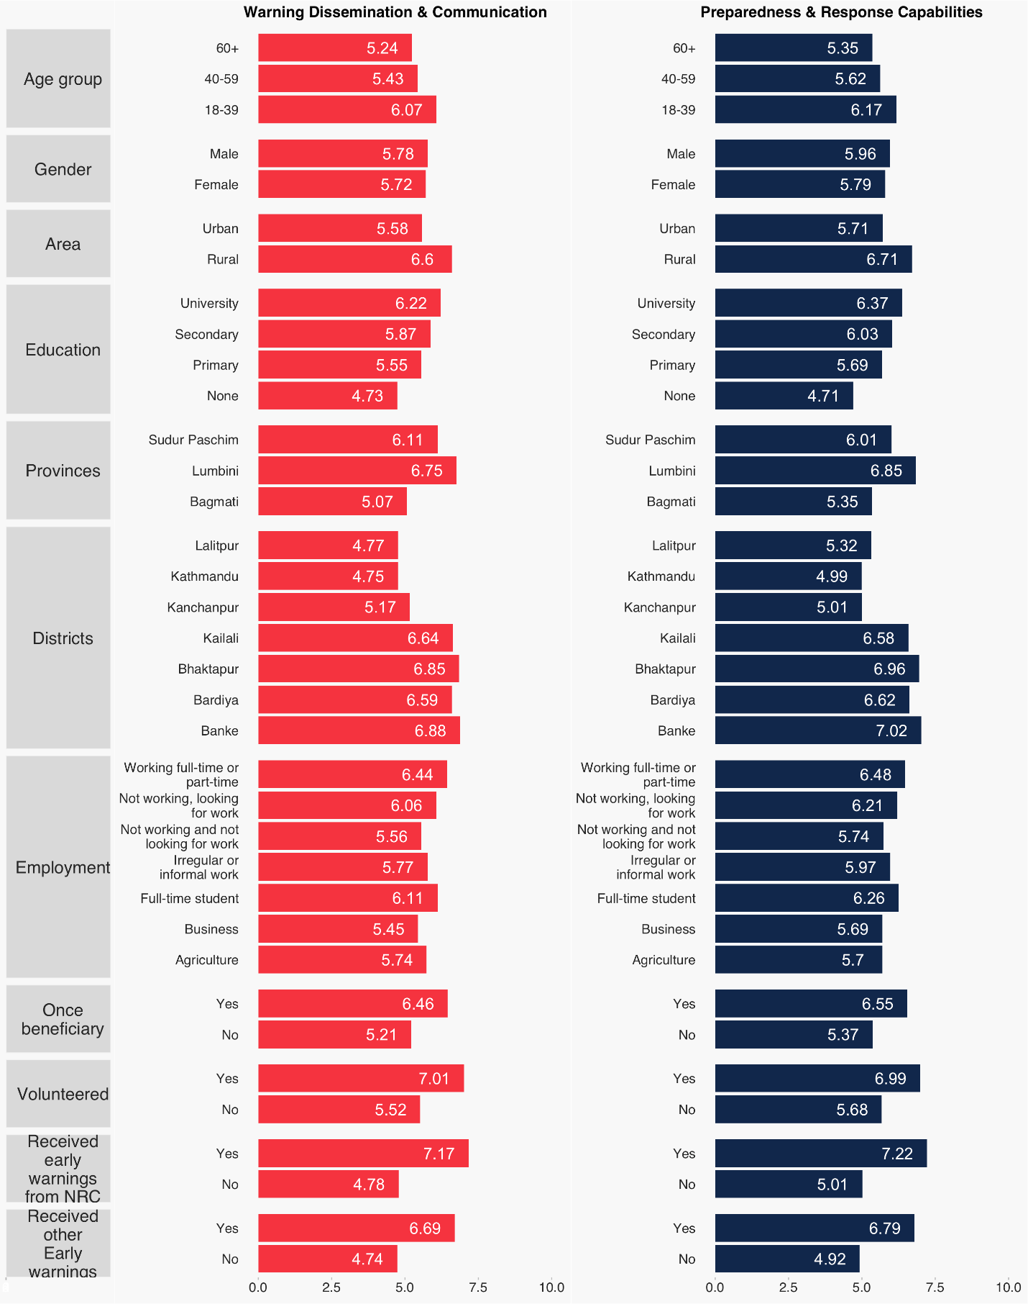

Score by Geographical area

Significant disparities exist across provinces and districts. At the provincial level, Lumbini Province records the highest scores for both communication (6.75) and preparedness (6.85), followed by Sudurpashchim Province (communication: 6.11; preparedness: 6.01), while Bagmati Province reports the lowest scores (communication: 5.07; preparedness: 5.35).

At the district level, Banke District (preparedness: 7.02; communication: 6.88) and Bhaktapur District (preparedness: 6.96; communication: 6.85) show strong performance. In contrast, Kathmandu District (preparedness: 4.99; communication: 4.75) and Lalitpur District (preparedness: 5.32; communication: 4.77) consistently record the lowest scores. The concentration of lower scores in Nepal’s most densely populated urban districts – where warning infrastructure might be expected to be stronger – suggests the need for further investigation into urban-specific barriers to effective Early Warning Systems.
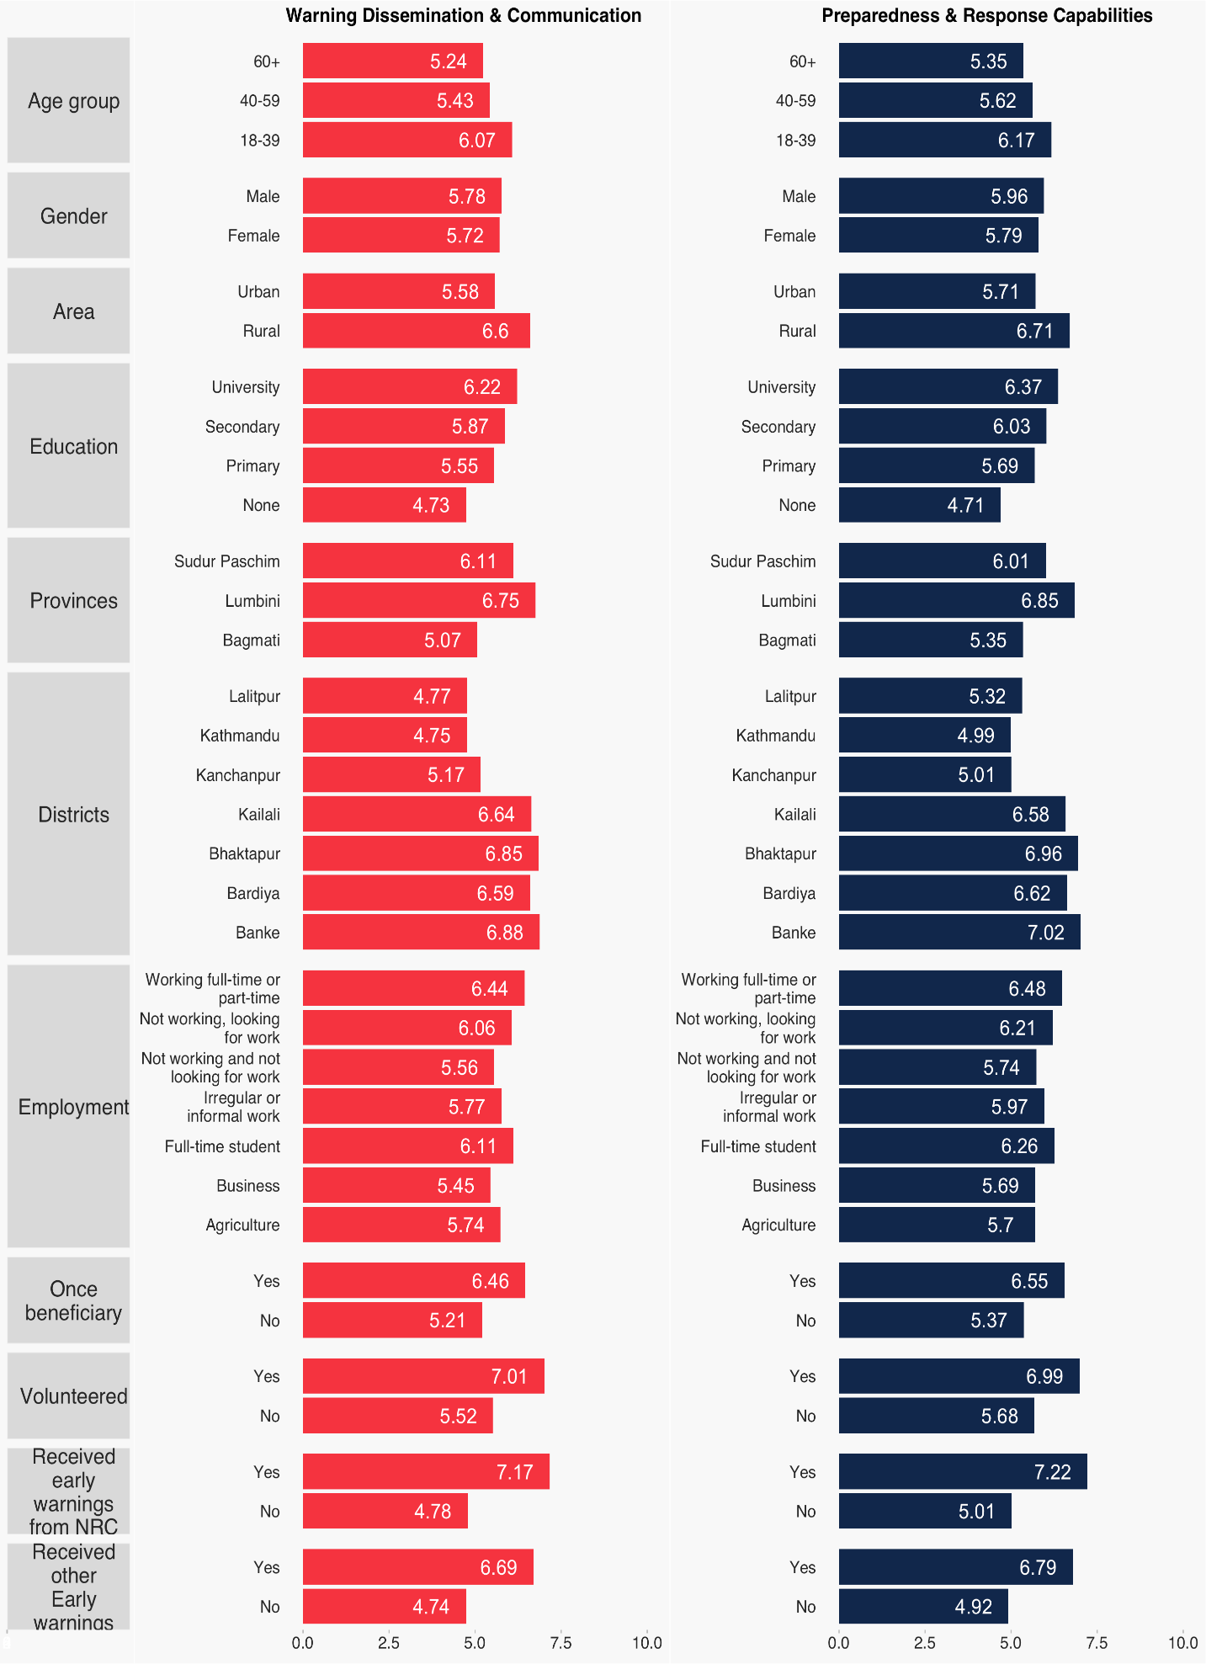

Impact of Warning Receipt on Trust Scores
One of the most striking findings is the strong association between receiving an early warning and reporting higher trust and preparedness scores. Respondents who received NRCS warnings scored substantially higher in both Communication (7.17 vs. 4.78 for those who did not receive warnings) and Preparedness (7.22 vs. 5.01). This gap of more than two points underscores the dual function of early warning receipt: it not only informs protective action but also builds institutional trust.
This finding reinforces the importance of maximizing warning reach – not only for immediate protective outcomes, but as a long-term trust-building mechanism. Respondents who received warnings from any source (NRCS or other) also outperformed those who received no warnings, suggesting that the source matters less than the act of receiving a timely, credible alert.

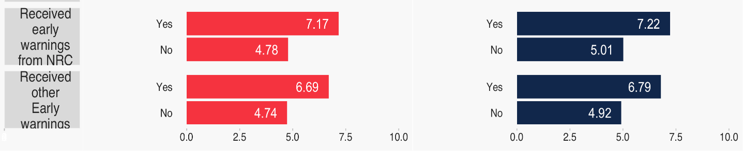
Warning Dissemination & Communication Preparedness & Response Capabilities
Above data reflects that Respondents who received early warnings (either from NRCS or other sources) scored significantly higher in both communication and preparedness compared to those who did not.
NRCS warnings had the greatest impact with Communication score (7.17 vs. 4.78) Preparedness score (7.22 vs. 5.01)

Strengths and challenges of CTI in Nepal:
CTI survey reinforced NRCS’s commitment to transparency and accountability, ensuring that the programs continue to meet community needs and build stronger relationships with local populations.
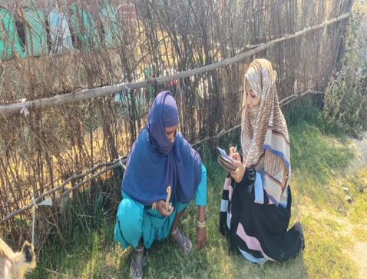
- District Chapters and stakeholders highly appreciated this initiative, as it marks the first time in NRCS history that community trust in its programs and services is being measured.
- The orientation held on different phases effectively equipped district volunteers with the tools and knowledge needed for the CTI Survey.
- The success of two-phases of CTI is a testament to the strong collaboration among diverse Red Cross and Red Crescent (RCRC) Movement members. This broad involvement, encompassing Community Volunteers, District and Sub-chapters, NRCS PMER/IM, CEA, and PGI teams, Global and Regional CEA teams, IFRC Nepal, British Red Cross, and Danish Red Cross in Nepal, showcases an excellent example of RCRC unity and shared purpose.
Photo 3: Data collection in Banke considering the inclusiveness.

Despite the above good practices, the team combated some challenges while conducting the CTI survey as such:
- Following the training, a portion of the newly trained volunteers discontinued their involvement in survey.
- Difficult in identifying the respondents as per the disaggregated sample size, mainly age and education wise was difficult in the community.
- Pre monsoon hampered in data collection in Kathmandu valley.
- 134 households denied interviews, especially from the urban area due to time requirements (tentative 30min) for completing the survey.

Recommendations from stakeholders and community to Strengthen Trust in NRCS
During the trust index survey conducted with the community and government stakeholders, the communities offered clear, actionable recommendations for the NRCS to not just maintain, but deepen community trust such as:
- Participation: Systematically engage community members (especially older adults, low-literacy groups, and urban residents) in the design and planning of warning and preparedness activities.
- Transparency: Establish clear, regular communication about how warnings are generated, by whom, and what communities should expect – building predictability and institutional accountability.
- Last-mile dissemination: Invest in expanding warning reach, particularly in urban districts (Kathmandu, Lalitpur) and among older and lower-educated populations, using trusted community-level intermediaries.
- Community engagement as trust infrastructure: Leverage the demonstrated link between prior EWS engagement and higher trust scores by prioritizing repeated touchpoints (drills, volunteer programs, awareness campaigns) as long-term trust-building investments.

Nepal Case Study | Climate Refugees | Othering & Belonging Institute
NRCS - Nepal Red Cross Society
IFRC GO - Emergency - Nepal: Floods EAP, 2024
NRCS - Nepal Red Cross Society

